A HISTORY OF HURLING IN DERRY CITY

John Ross, a Presbyterian born in Derry in 1853, was a captain of Dublin University Hurley Club in the 1870s, with Edward Carson on his team. His aptitude at ‘hurley’ may have derived from childhood experience of camán, for this short-lived hybrid sport at Trinity College resembled embryonic hockey in ground-play style and rules more than hurling per se. Sir John Ross later served as a Unionist MP for the city, judge and the last Lord Chancellor of Ireland in 1921-22.

The historical roots of hurling in the city of Derry are complex and ancient, as illustrated by the quotation above from the work of historian Donal McAnallen and by the depiction of a camán-like stick and ball on a sixteenth-century grave-slab in the city's hinterland at Clonca, Inishowen.

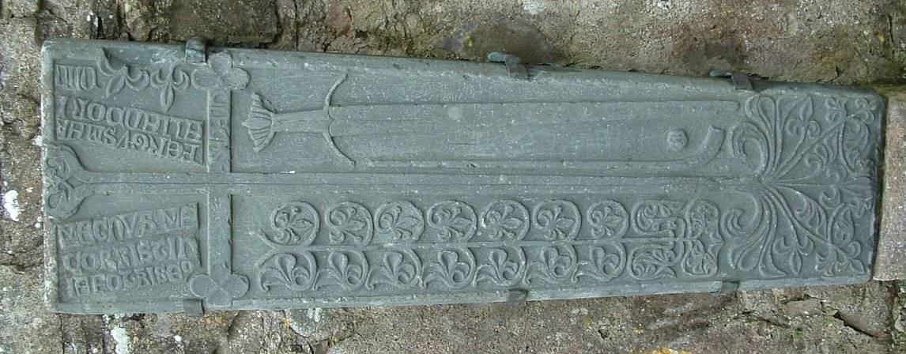

By securing the support of Derry City Council and the Arts Council of Northern Ireland for a legacy project with history at its core, Derry's only hurling and camoige club, Cumann Báire Na Magha, was able to commission Donal McAnallen to research and write a history of the game in the city and region.

Na Magha tasked the historian to undertake primary and secondary historical research and to write an extended essay that would put on record an important piece of social and cultural history. Furthermore, Na Magha passed the historian's draft to musicians and composers John McSherry and Donal O'Connor and commissioned them to write a new suite of traditional music entitled The Na Magha Hurling Suite. Thus formal historical research is being used as a cultural springboard into musical composition and performance.

Na Magha will include young hurling and camoige players in musical workshops and performance with the composers, working up to a full performance of the new suite, given by a quintet of professional traditional musicians, in Derry's premier civic building, The Guildhall, on 9th May 2015. The foundation of this work is the historical research undertaken by Donal McAnallen.

Hurling and camoige, as manifestations of non-sectarian sporting and cultural activities, persist in the city. Many of the economic, social, political and religious challenges to this tradition are seen in McAnallen's engaging essay. Notably, players faced the wrath of Sabbatarians from Protestant and Roman Catholic authorities, though Sunday was the only day when 19th and early 20th century workers were free to play.

Derry's rural hinterland in Donegal provided notable rivalries, with a strong tradition of the game along the banks of Lough Swilly.

The playing of matches in the 1860s-70s between teams from Burt and Newtowncunningham is documented in various retrospective sources. Challenge games took place on an annual basis at Christmas or New Year. Up to forty men per side took part, shooting for goals only, with no designated positions, no referee and no prizes other than the losing team on occasion having to buy a round of drinks for the victors in the pub.

One of the aims of the Derry City Council and Arts Council of Northern Ireland Legacy Project Funding, developed as a follow-up to the city's designation as UK City of Culture in 2013, is to bring 'the edge into the centre'. Na Magha intends to bring hurling and camoige from the edge of the city's sporting life right into the centre.

Na Magha will publish McAnallen's final draft on websites and use it, as extracts, in educational and display opportunities, in association with club events. It is likely that some quotes will appear on hoardings planned to surround the club pitch, situated at Ballyarnet on the edge of Derry, where Amelia Earhart, the American aviatrix, landed in 1932.

In a sense this historical work by Na Magha paraphrases Fernand Braudel's famous description of history – History may be divided into three movements: what moves rapidly, what moves slowly and what appears not to move at all. - into a 'game of two halves'. Now, in a second half with the wind of History turned by peace and political processes, however faltering, there is an impulse to link an ancient, traditional practice of faux-conflict, manifest as sport among men and women, into a modern engine of pleasure, health, well-being and cultural excitement.

Dave Duggan is a dramatist and novelist, living in Derry. He is a former player with, and now a member of, Na Magha, Derry's only hurling and camoige club.

742 words
1 image

